

19CSCI03P

Principles of Web Programming

Sport news & Events (Yalla-goal)

Members:

|  |  |  |
| --- | --- | --- |
| ID | Student Name | BUE E-mail |
| 200259 | Mazen Tarek (Group Leader) | Mazen200259@bue.edu.eg |
| 201541 | Ziad Mostafa | [Ziad201541@bue.edu.eg](mailto:Ziad201541@bue.edu.eg) |
| 196643 | Abdelrahman Walid | [Abdelrahman196643@bue.edu.eg](mailto:Abdelrahman196643@bue.edu.eg) |
| 194498 | Youssef Sherif | Youssef194498@bue.edu.eg |

**Site Map:**

**Wireframe:**

* leagues wireframe

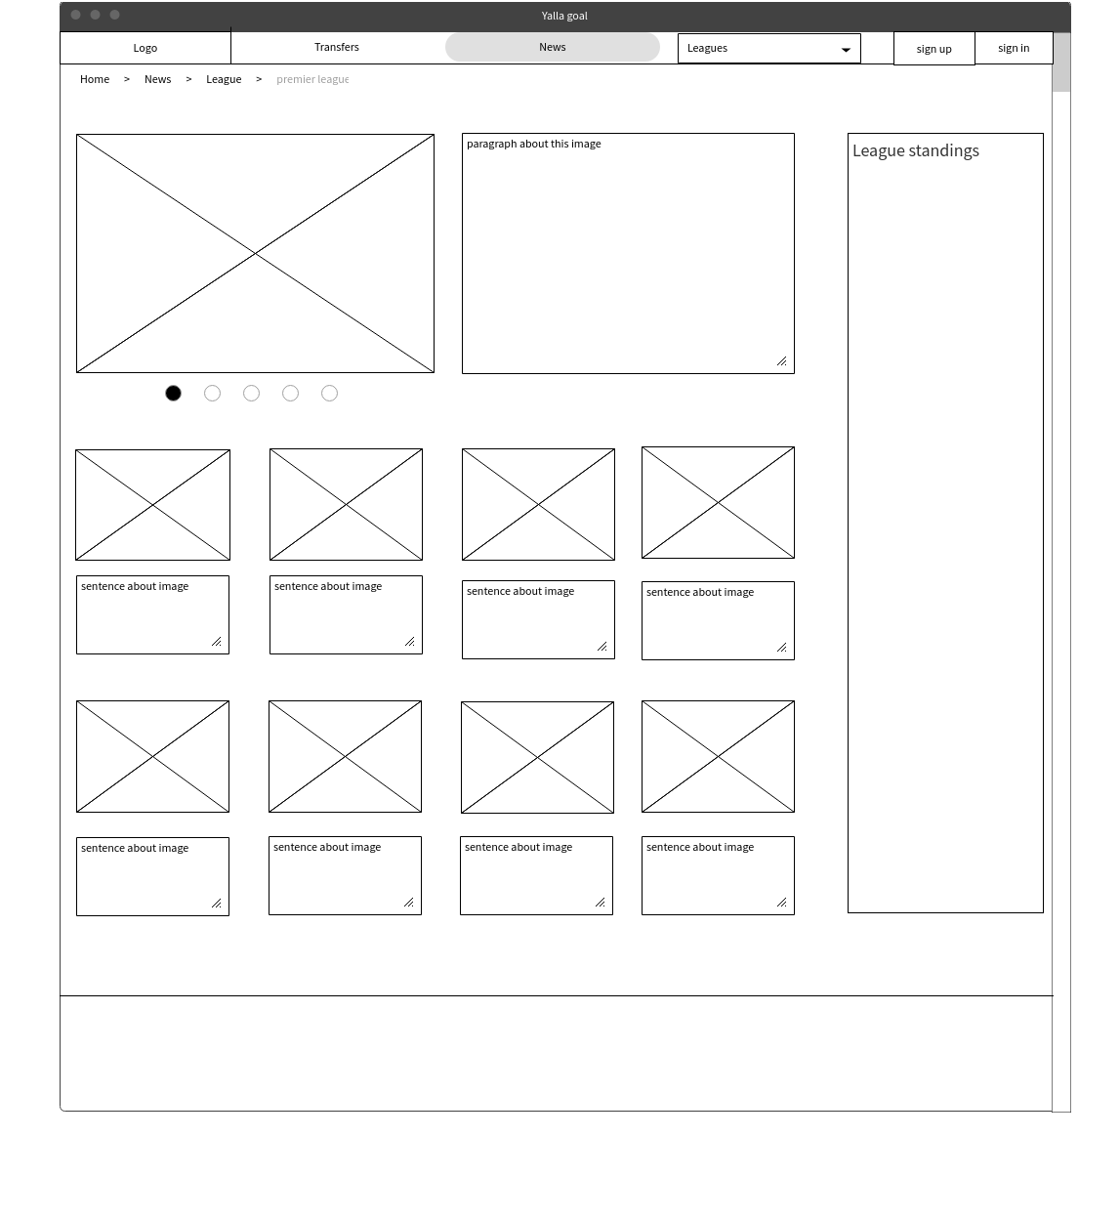

Home and News wireframe

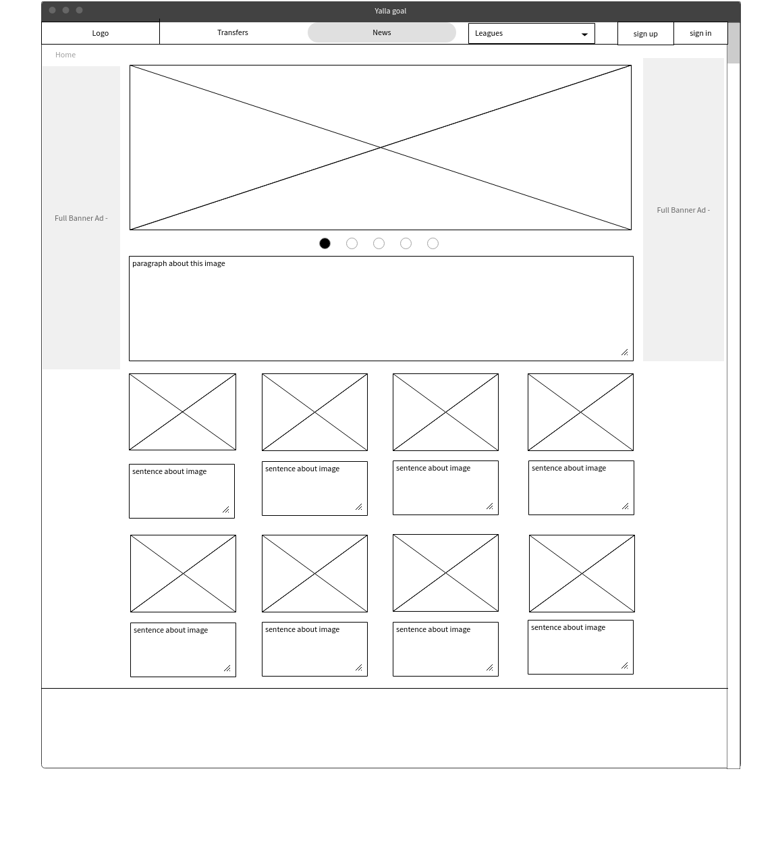

* News article wireframe

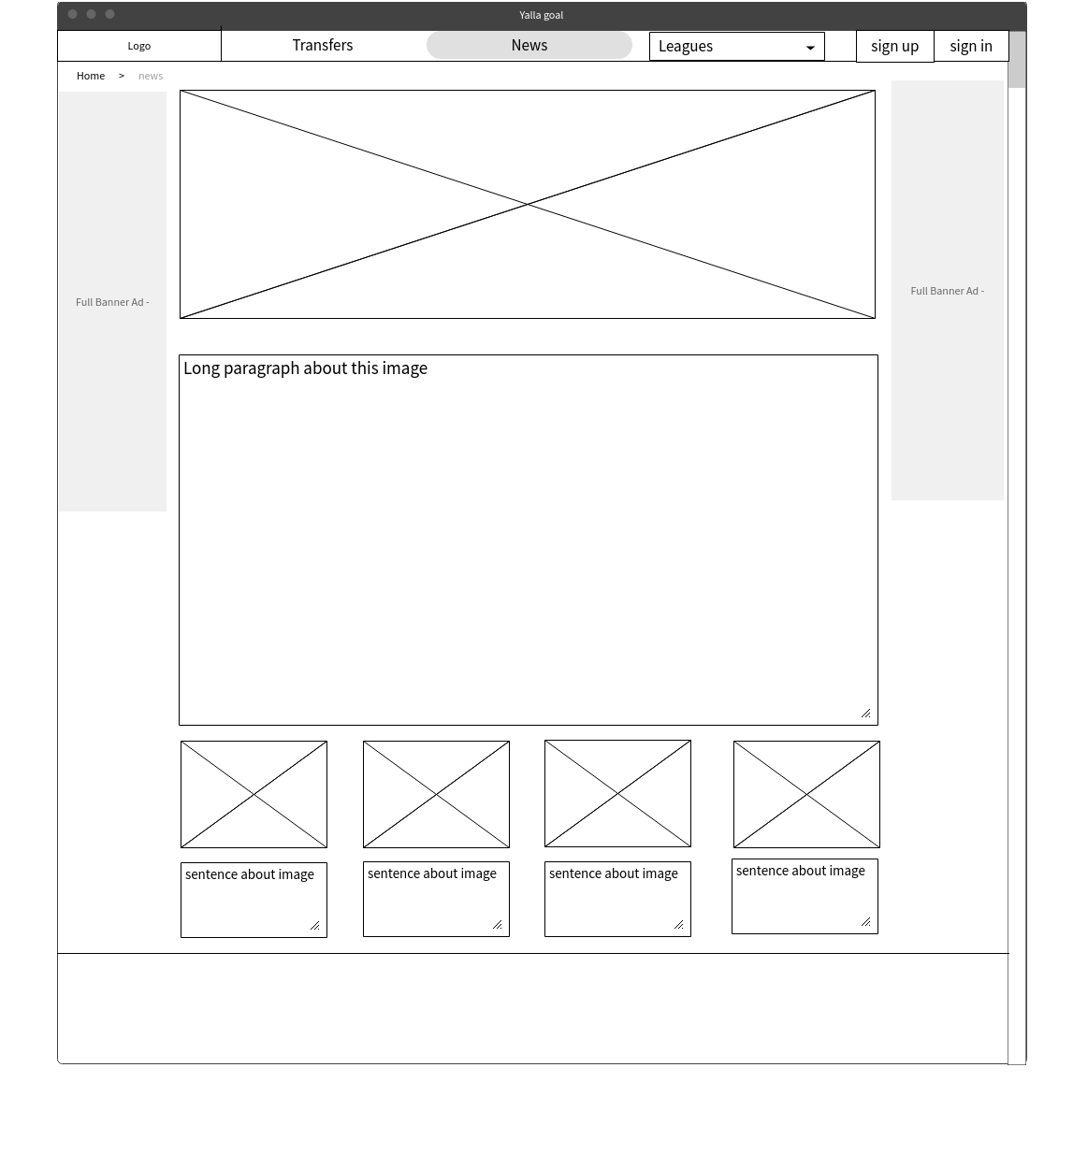

* Sign in wireframe

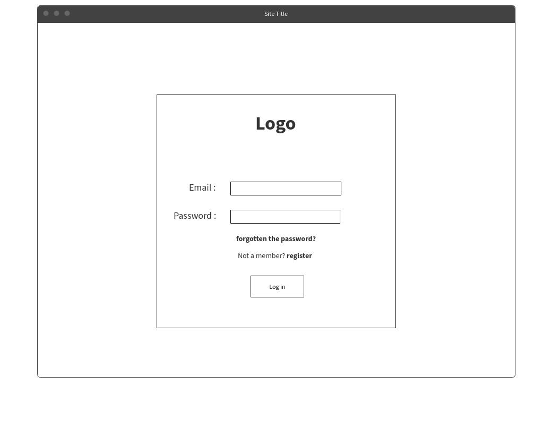

* Sign up wireframe

The sign-up form in the first step will contain details about the user (Username, Email, Phone number, Password, Confirm Password, gender). Then in the second phase, the user selects whatever he wants from these leagues and cups to follow them, the third one announce to you how can the web site communicates with to send you the latest news of the leagues you have been selected.

1. First step in registration.

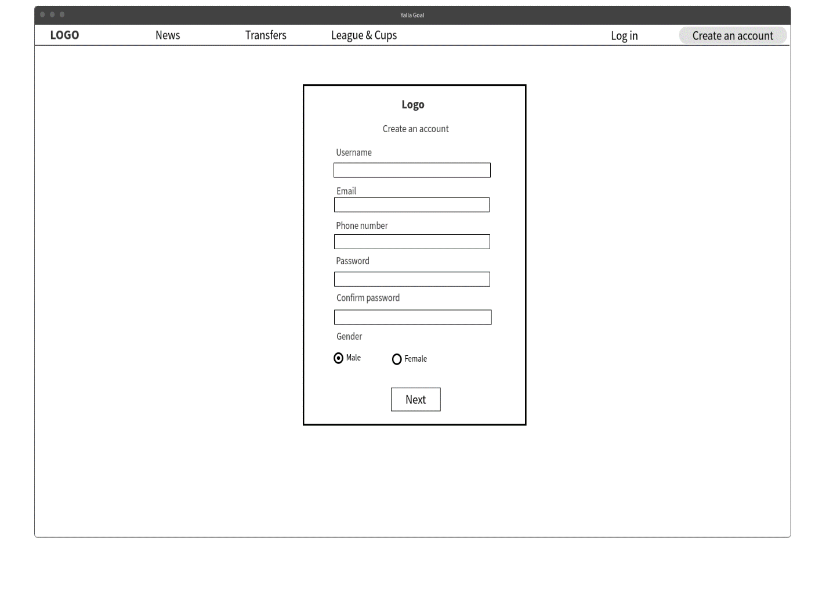

2-second step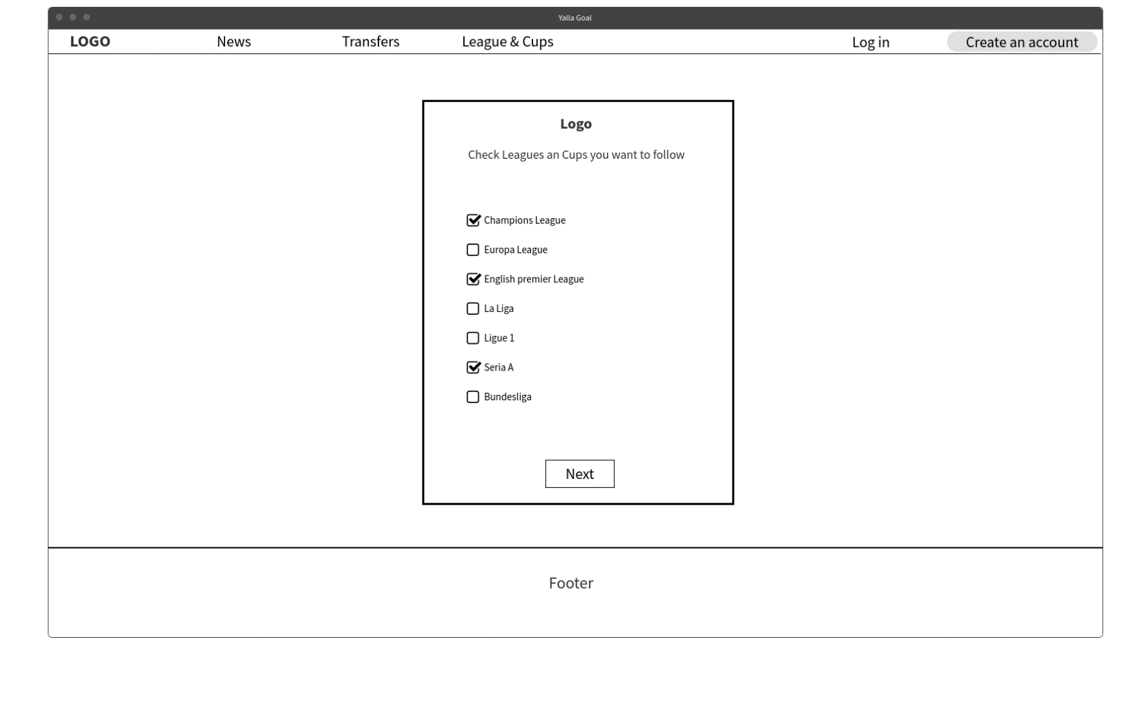

3-third step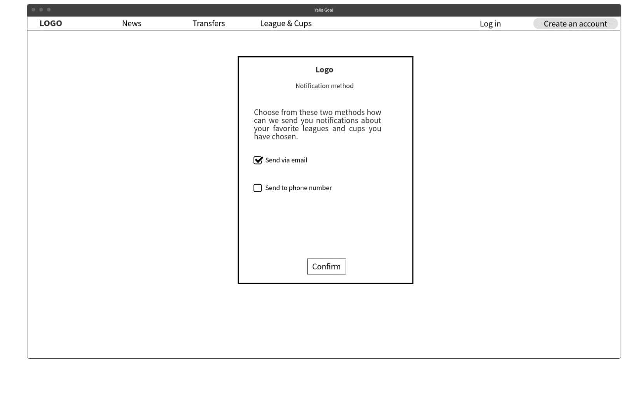

* The explanation of the tables

The tables that we choose to make shows us the standings of the teams in a specific league , the tables gives us information about the name of the teams in this specific leagues and the points that teams collected through the competition , and how many matches they played ? and show how many times the teams won , lost and draw . Second table is considered with each league players considering player status like :- Appearances , Goals , Assists , Yellow Cards , Red Cards , Goal per match ratio , Shots on Target , Shots , Penalties Scored , This will include the player status that the audience is attracted to and give them the ability to be interactive with their favorite player .

